A

Mini Project Report

On

**SCHOOL MANAGEMENT SYSTEM**

|  |  |  |  |  |
| --- | --- | --- | --- | --- |
| **TABLE OF CONTENTS** | | | | |
|  |  | | | **Page No.** |
|  | |  |
| **CHAPTER 1** | **INTRODUCTION** | | | **1-3** |
|  | 1.1 problem description | | | 2 |
|  | 1.2 system requirement  1.2.1 hardware requitrement  1.2.2 software requirement | | | 2 |
|  | 1.3 limitations of project | | | 2 |
|  |  | | |  |
| **CHAPTER 2** | **Database design** | | | **4-9** |
| **CHAPTER 3** | **Welcome to sms** | | | **10-13** |
|  | 3.1 design view | | | 10 |
|  | 3.2 source code | | | 10 |
|  | 3.3 run view | | |  |
| Chapter 4 | Café time  4.1 menu card  4.2design view  4.3 run view  4.4 source code | | |  |
| Chapter 5 |  | | |  |
|  | Library management  5.1 design view  5.2 run view  5.3source code | | |  |
| Chapter 6 | Transport facility  6.1 design view  6.2 run view  6.3 source code | | |  |
| Chapter 7  Chapter 8 | Fee portal  7.1design view  7.2 run view  7.3 source code  Profile management  8.1 students profile  8.2 profile updation | | |  |

|  |  |  |
| --- | --- | --- |
| **LIST OF FIGURES** | | |
| **FIGURE NO.** | **FIGURE NAME** | **Page No.** |
|  |  |  |
| 1  2  3  4  5  6  7  8  9  10  11  12  13  14  15 | user login design view  user login run view  retrieve password  main page  café design view  menu card  café run view  library design view  library run view  transport design view  transport run view  fee portal design view  fee portal run view  student profile  profile updation |  |
|  |  |  |
|  |  |  |
|  |  |  |
|  |  |  |
|  |  |  |
|  |  |  |
|  |  |  |
|  |  |  |
|  |  |  |
|  |  |  |
|  |  |  |
|  |  |  |
|  |  |  |
|  |  |  |
|  |  |  |

**PROBLEM DESCRIPTION**

This project is made to solve the purpose of a **SCHOOL MANAGEMENT SYSTEM**.It fulfills all the needs of a SCHOOL. As it is very difficult to record all the data manually in a register and do operations in it, this project makes all these processes easy.

As today the world is becoming more computerized, this project meets the demand of this world.

**SYSTEM REQUIREMENT**

* INTEL PROCESSOR SPEED : 500MHz
* RAM:128 MB FOR CLIENT AND 512 MB FOR SERVER.
* WINDOWS 98/XP/2000/NT.
* J2SE PLATFORM 6.0,5.0 UPDATE 9/13.
* JAVA DEVELOPMENT KIT.
* INTEGRATED DEVELOPMENT ENVIRONMENT(IDE)-NET BEANS.
* MySQL VERSION FOR WINDOWS (x86).(MySQL 4.0 OR 5.0 OR HIGHER).
* MySQL JDBC DRIVER.

HARDWARE REQUIREMENTS:

* RAM
* Hard disk
* Internet connection
* processsor

SOFTWARE REQUIREMENTS:

* Operating system
* Database server
* Language
* Compatible browser

**LIMITATIONS OF THE PROJECT:-**

1. Do not delete the last package, it will cause the malfunctioning of the project.
2. It does not permit student-teacher communication.
3. Password cannot be changed.

**DATABASE DESIGN.**

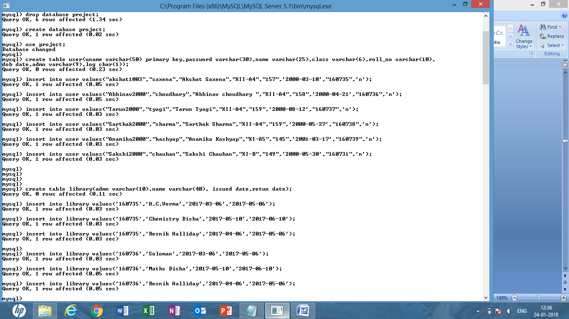

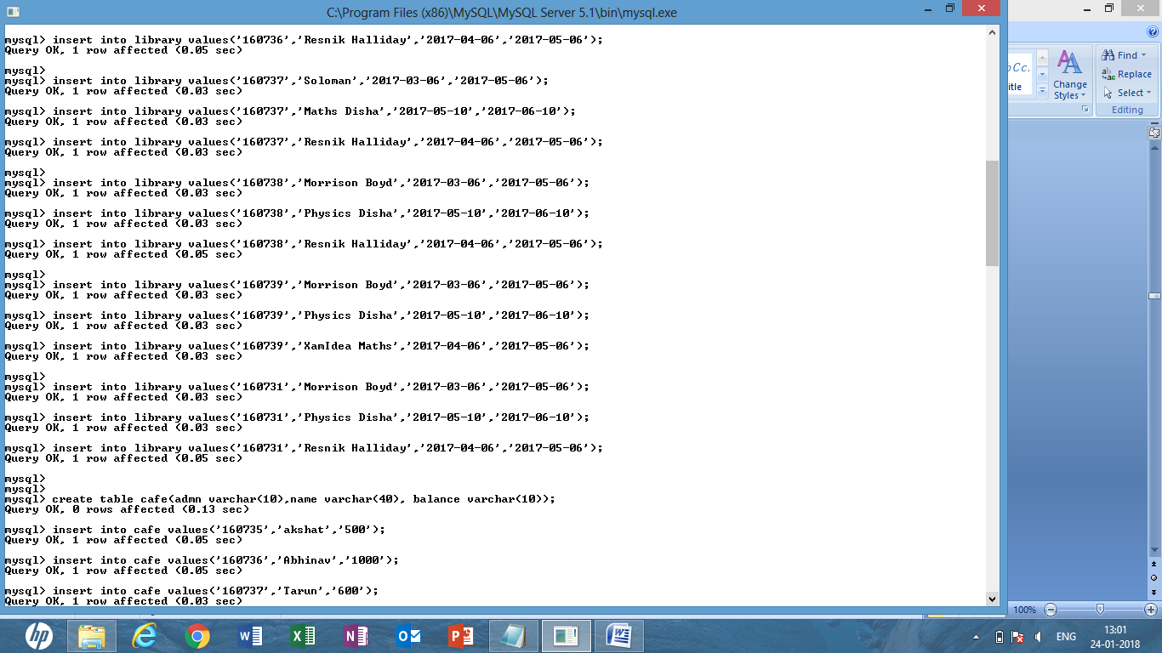

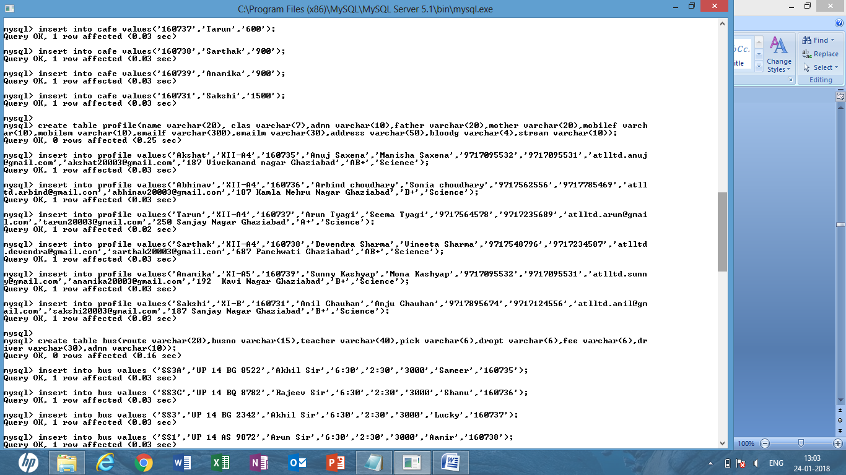

**WELCOME TO SMS:**

DESIGN VIEW:

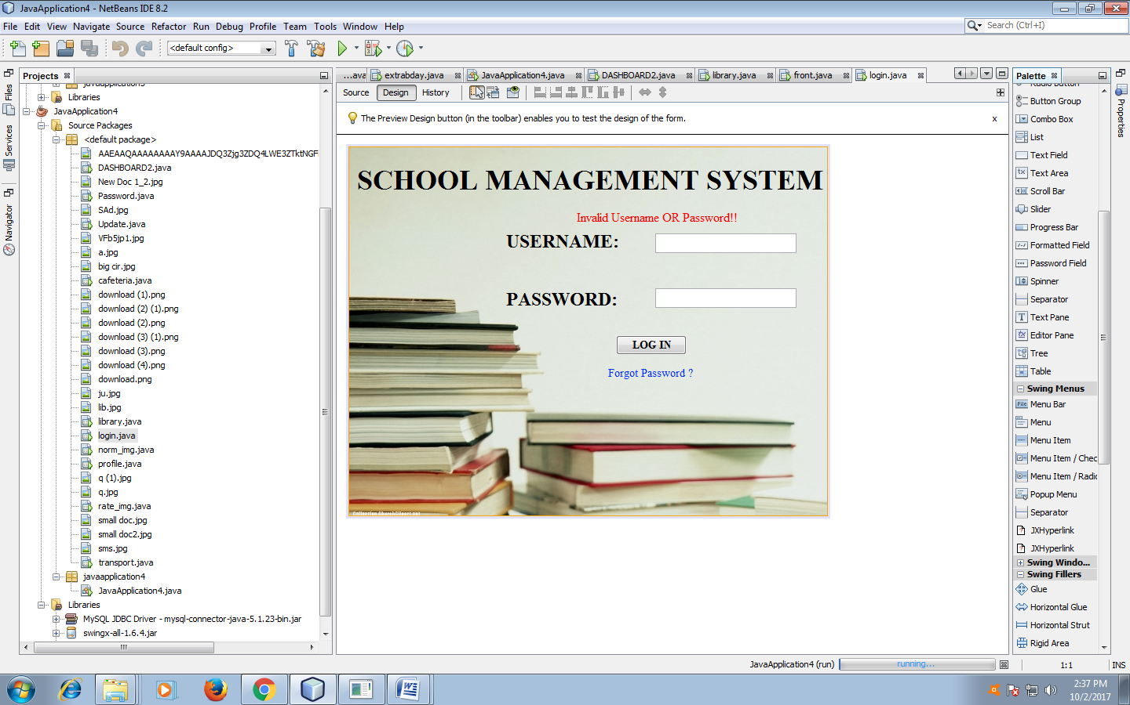

Fig 1: user login design view

RUN VIEW:

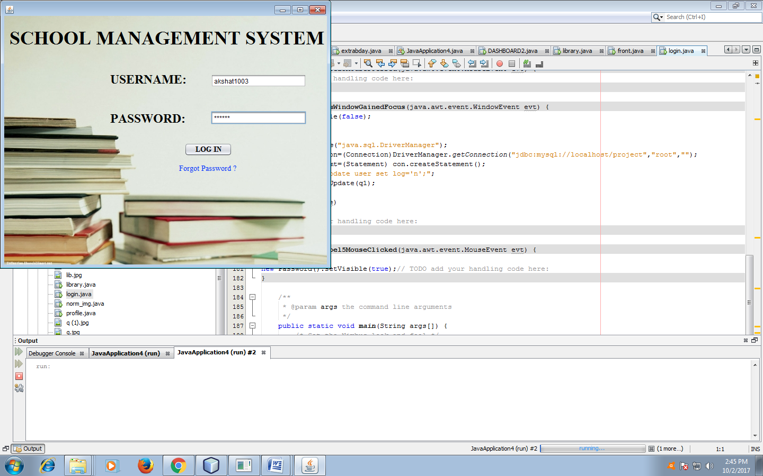

Fig2 :user login run view

SOURCE CODE:

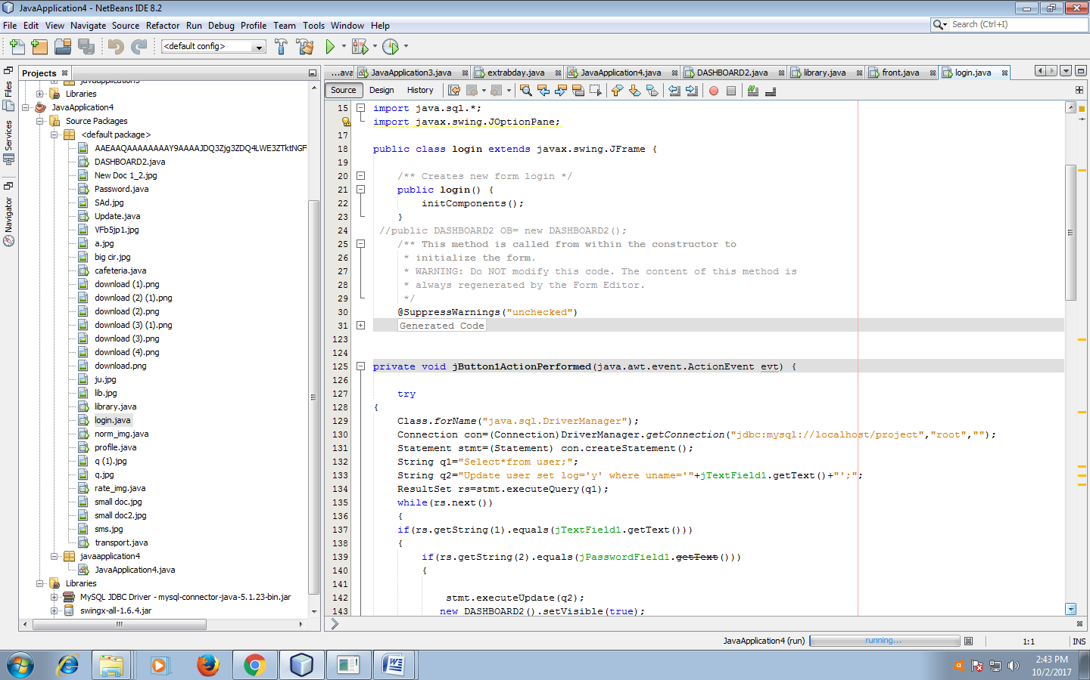

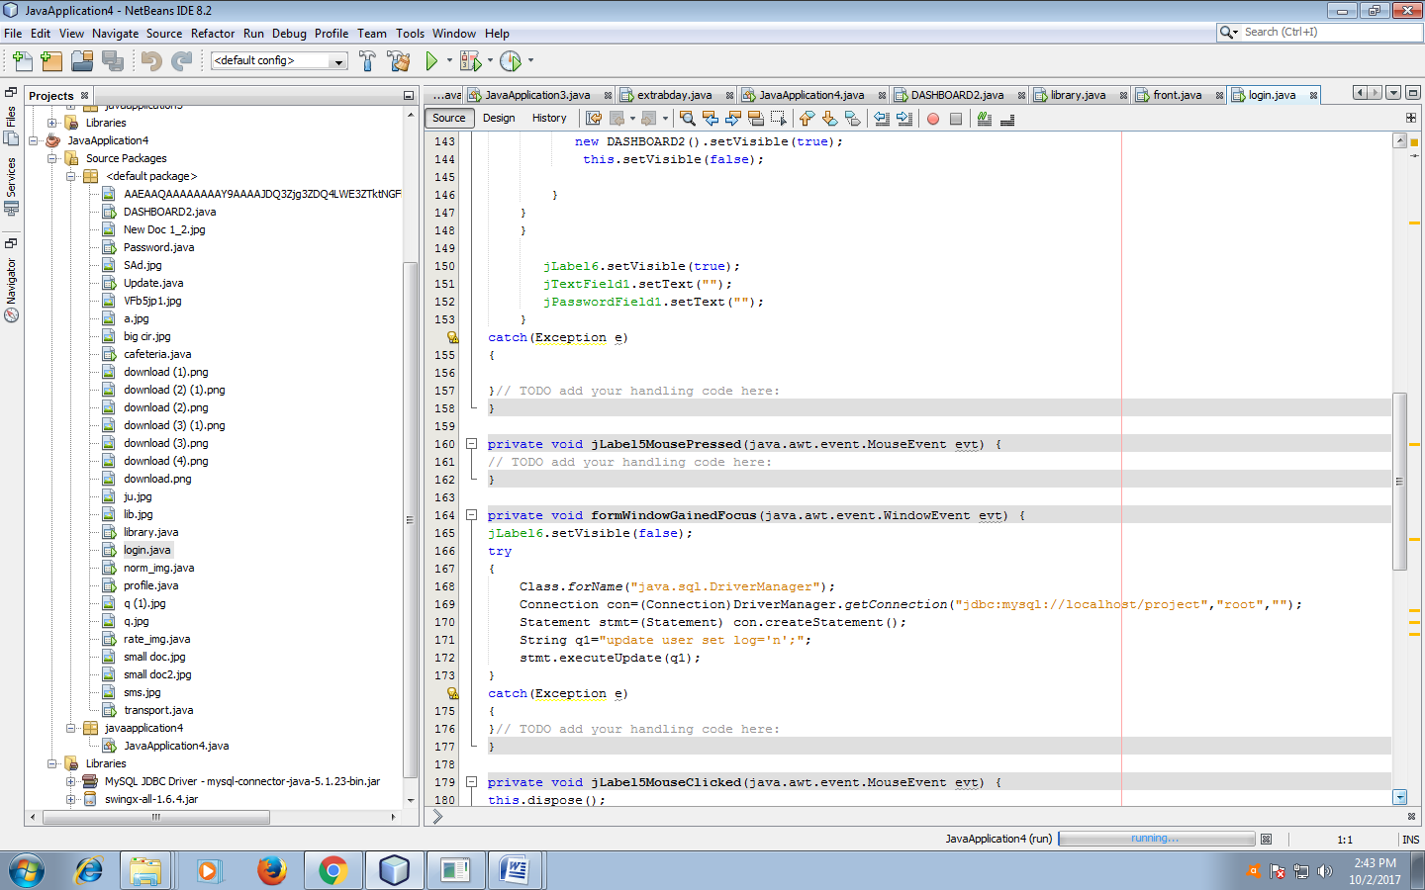

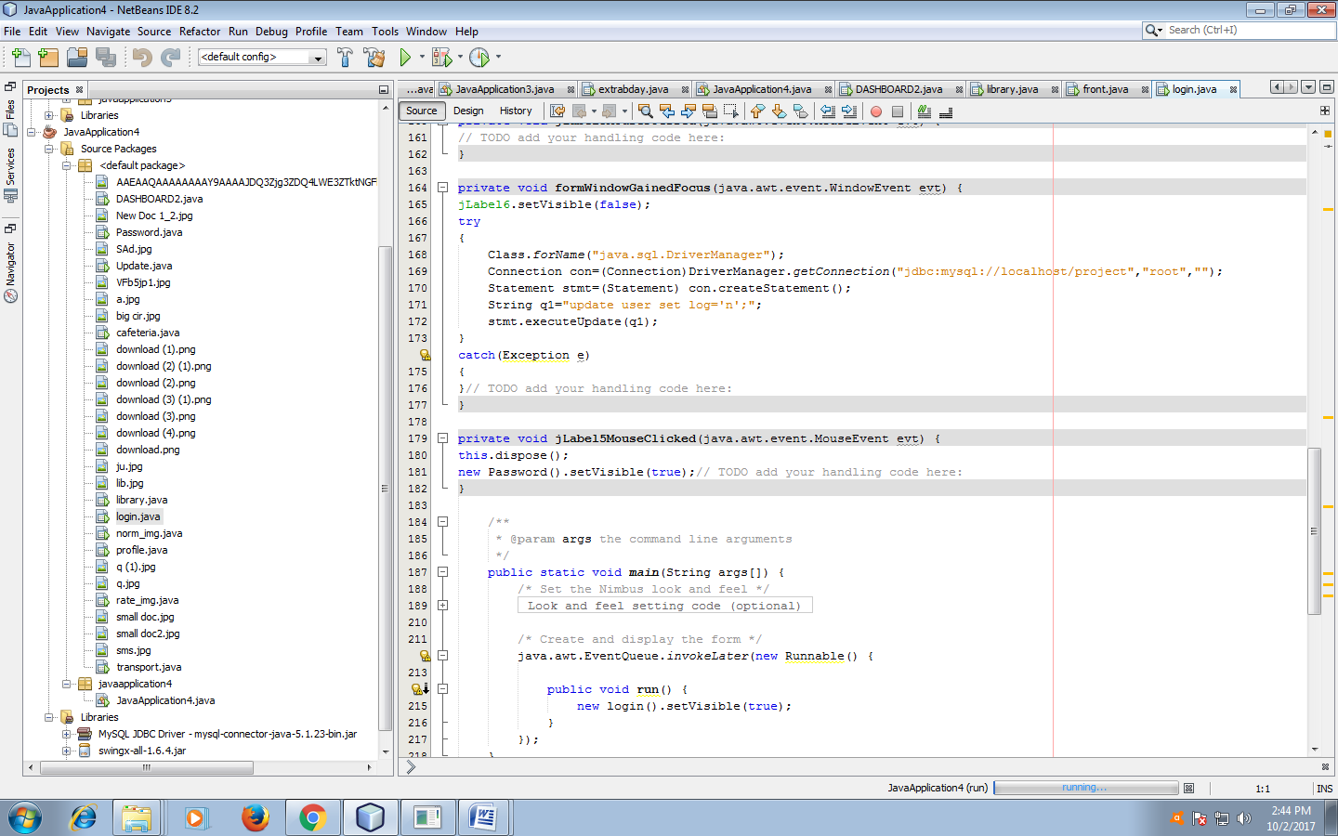

**DESIGN VIEW:**

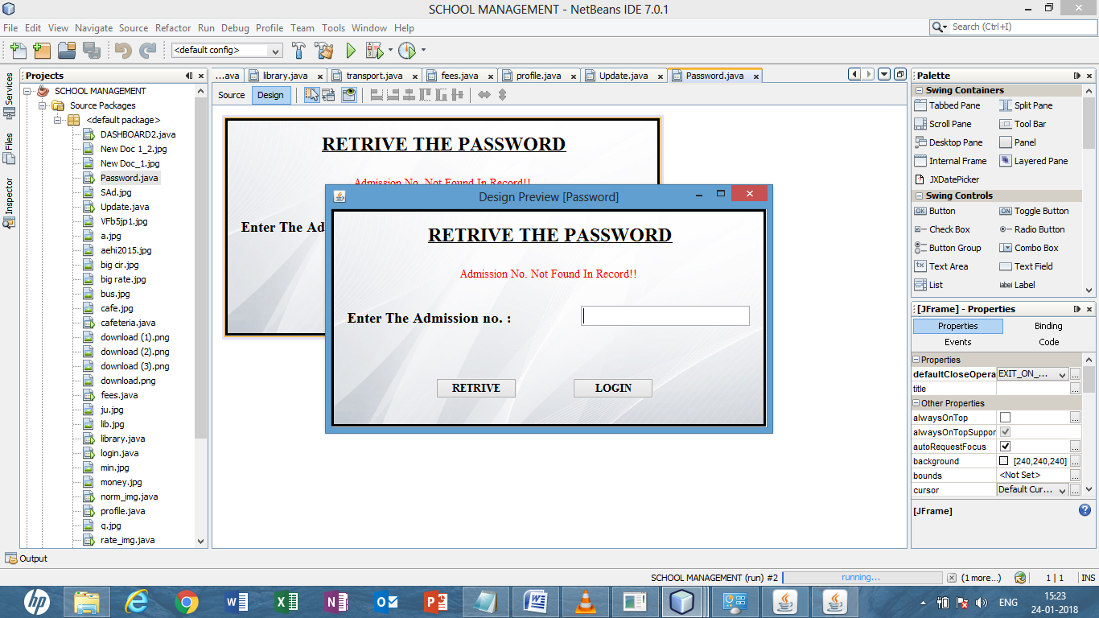

RUN VIEW:

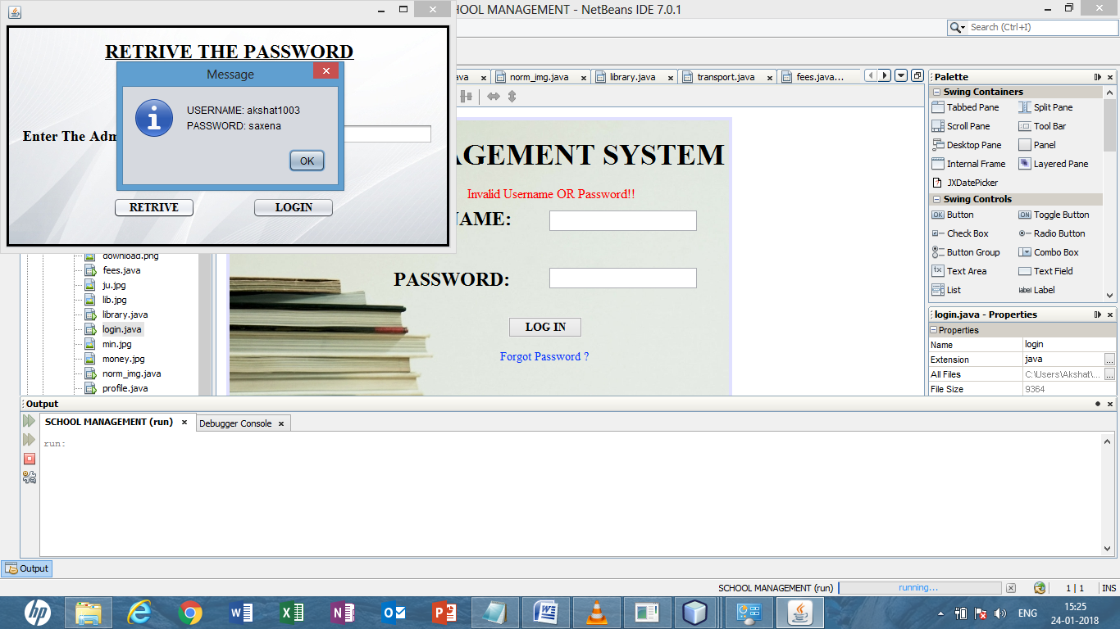

**Fig 3:retrieve password**

SOURCE CODE:

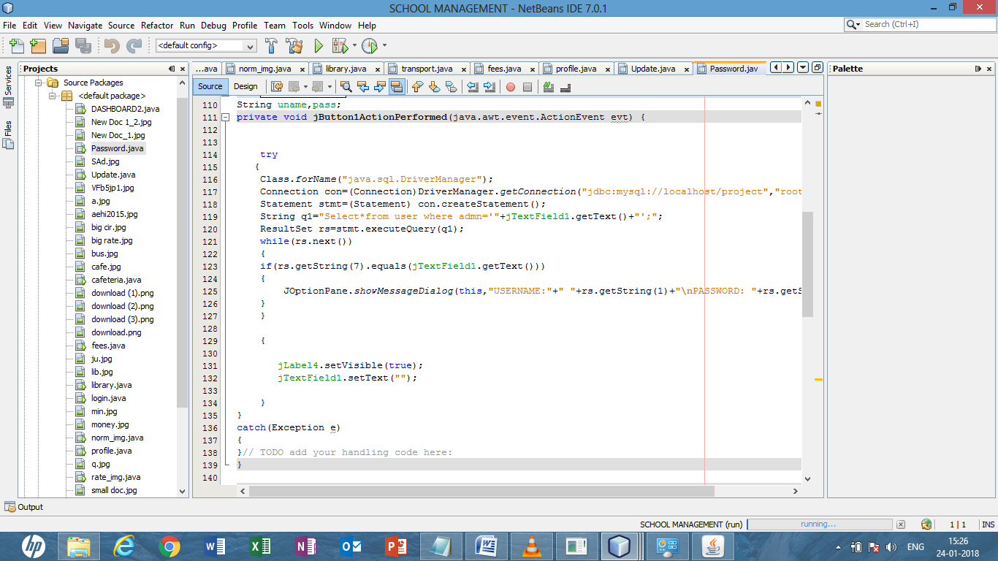

**MAIN PAGE:**

**DESIGN VIEW:**

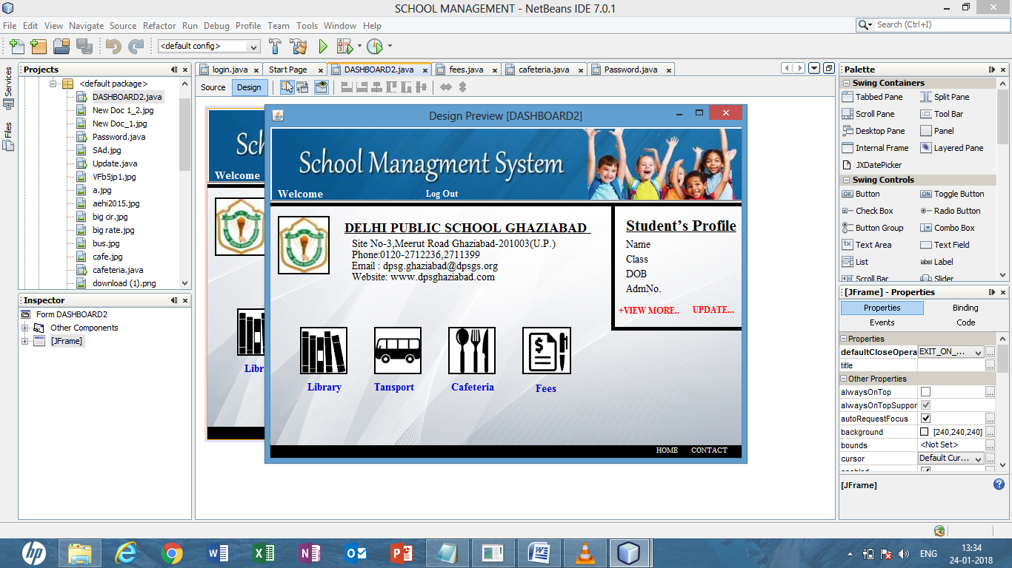

Fig 4:main page

RUN VIEW:

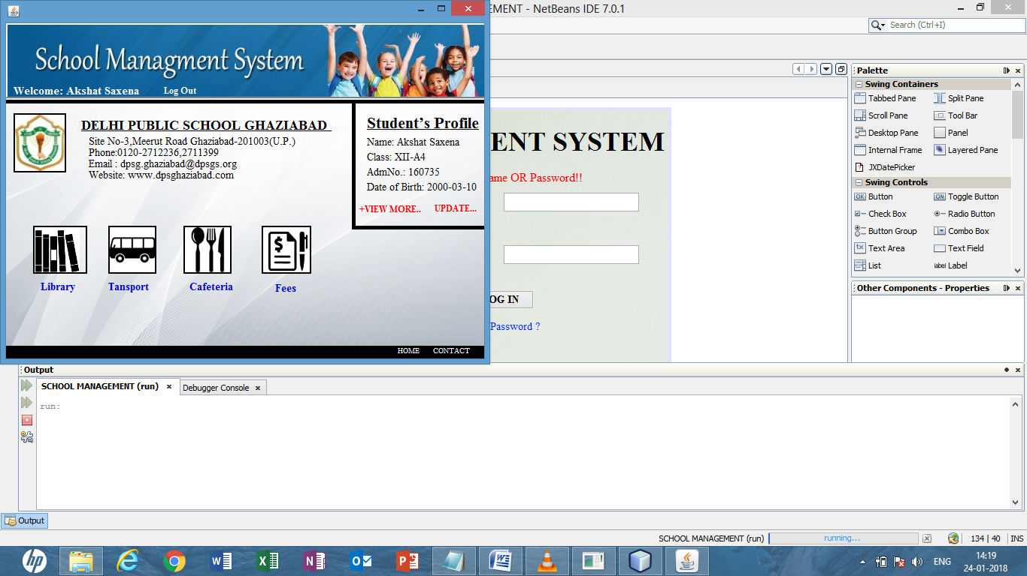

SOURCE CODE:

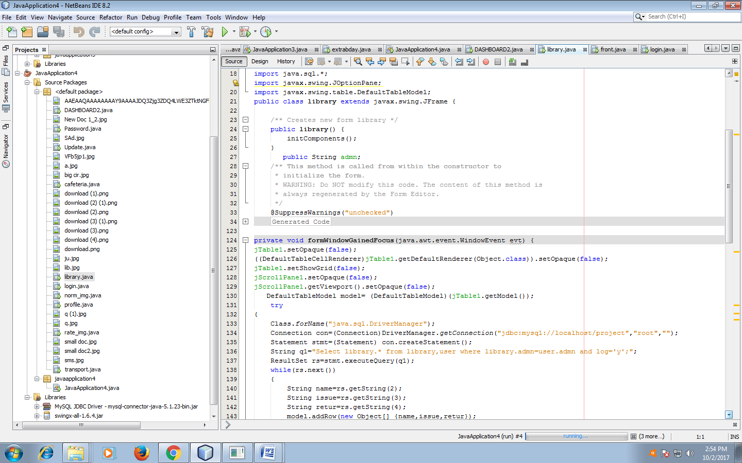

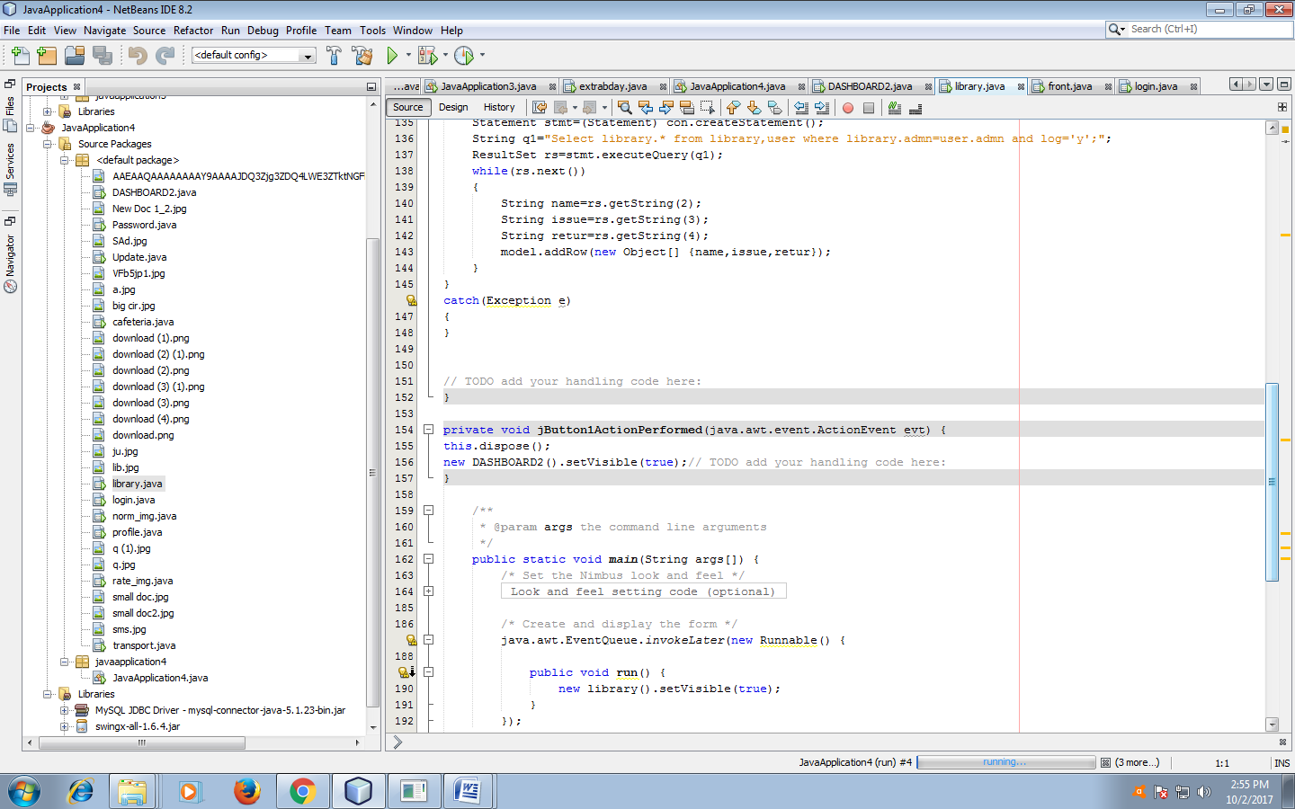

**CAFÉ TIME:**

**DESIGN VIEW:**

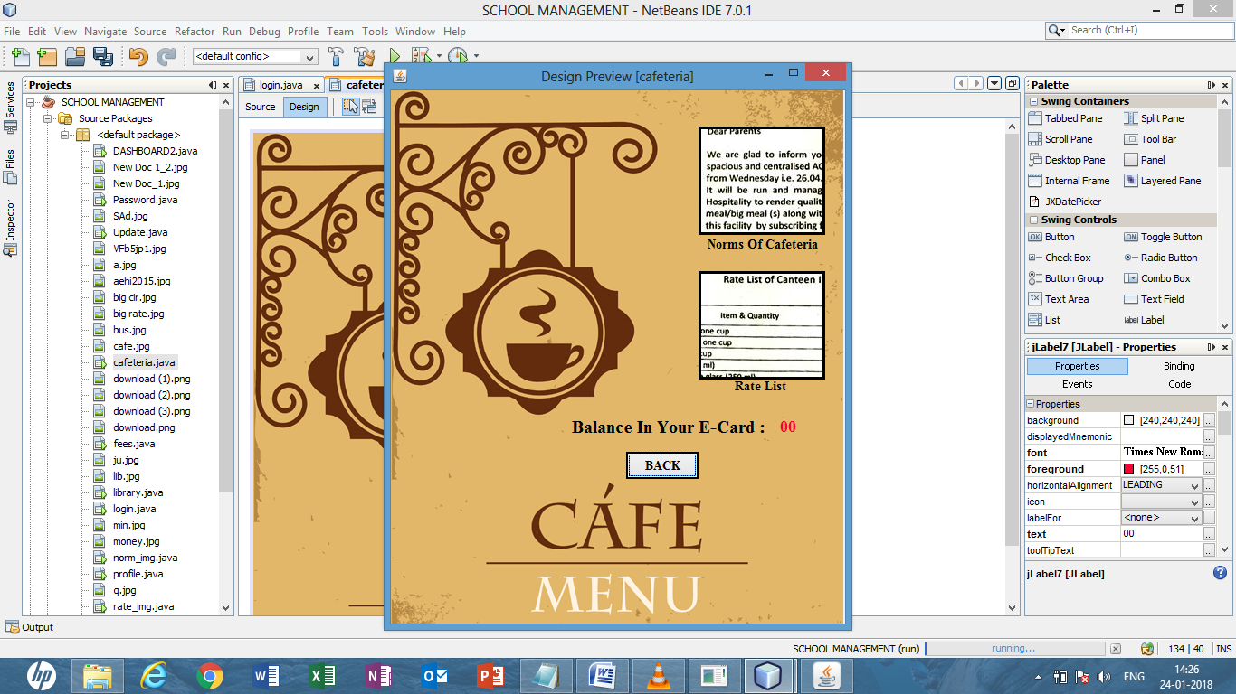

Fig 5: café design view

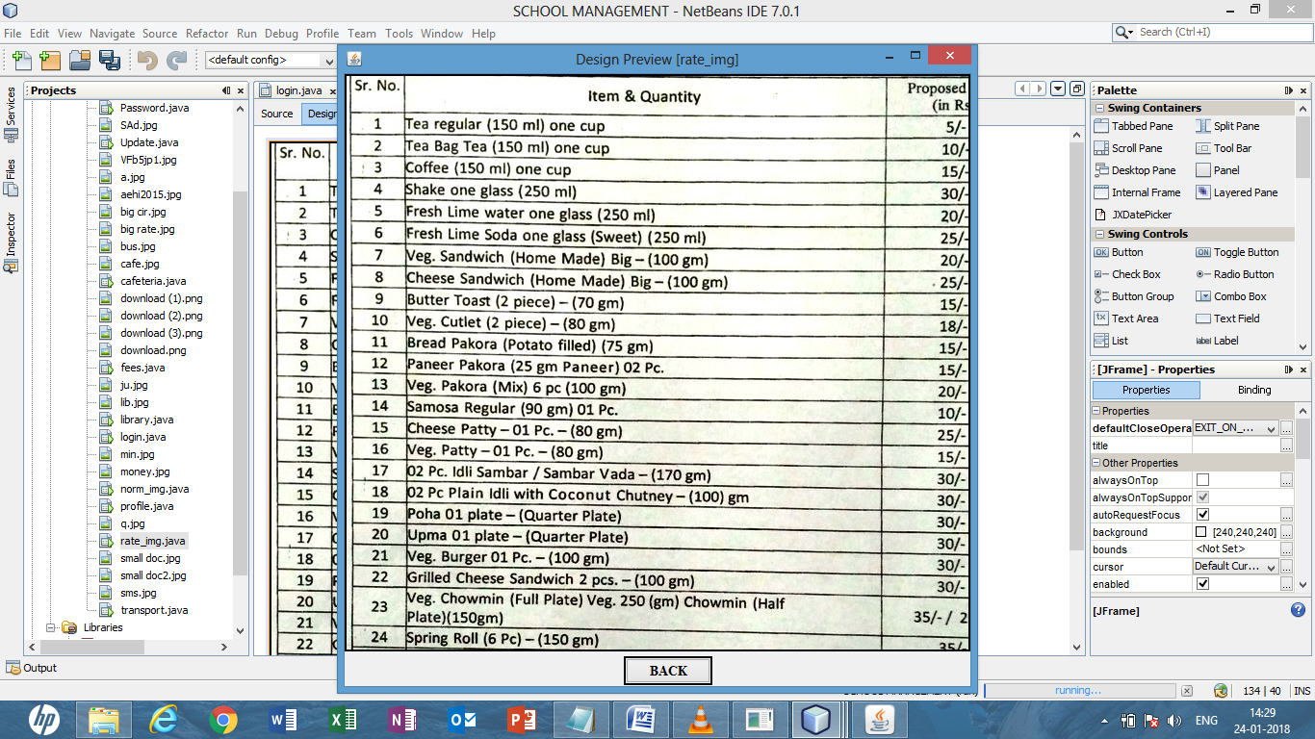

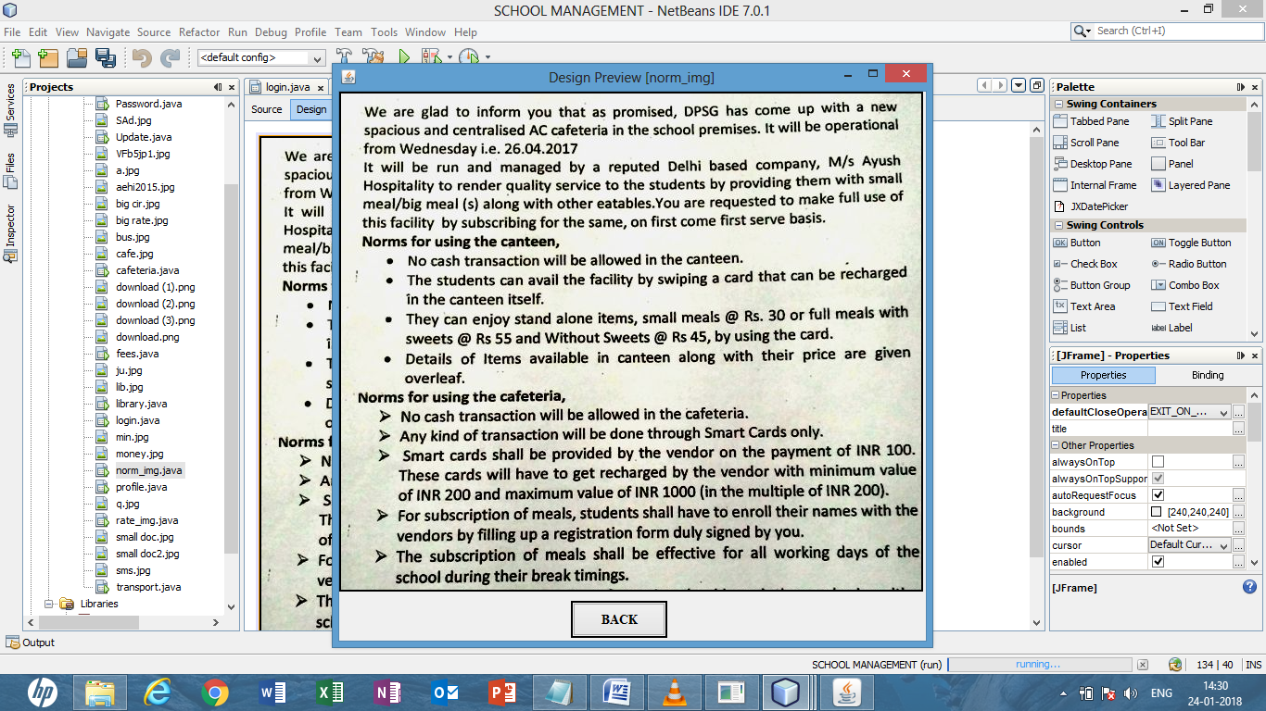

Fig 6:menu card

RUN VIEW:

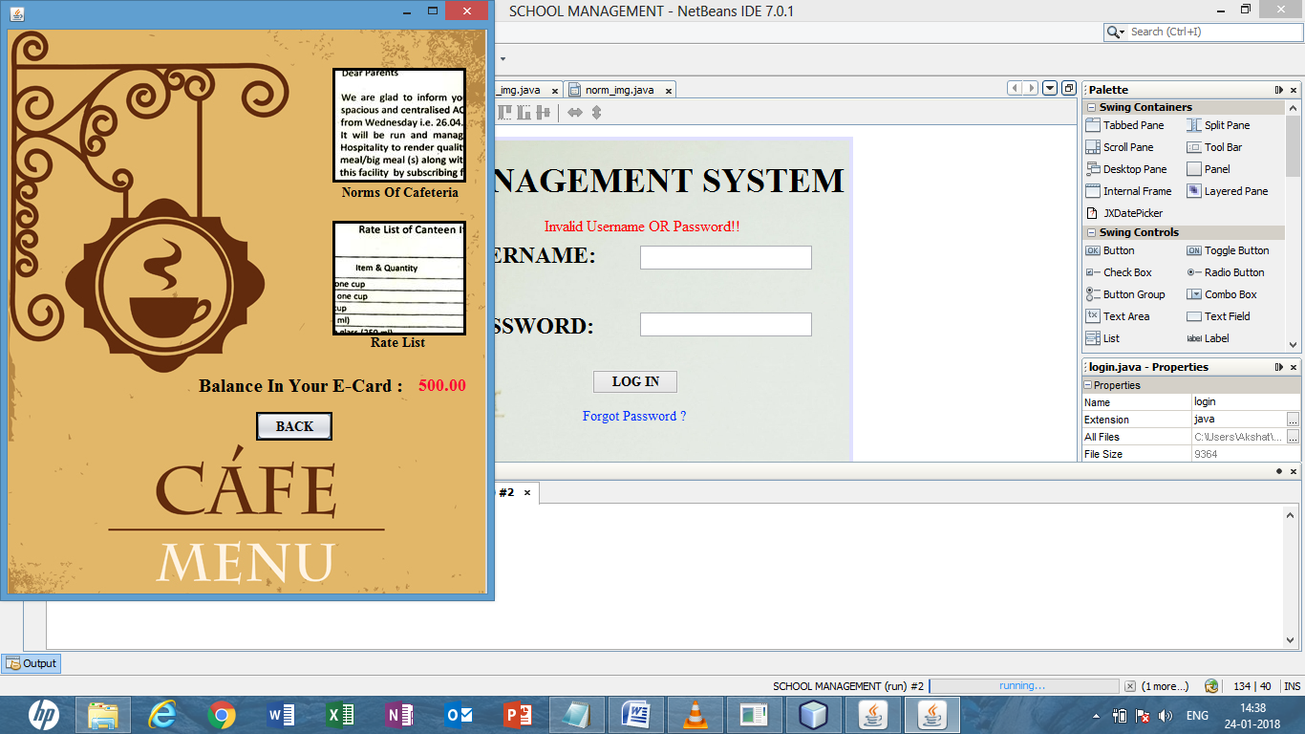

Fig 7: café run view

SOURCE CODE:

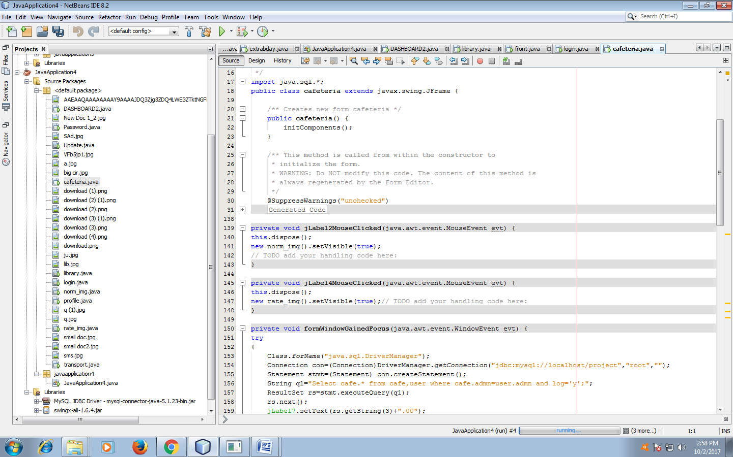

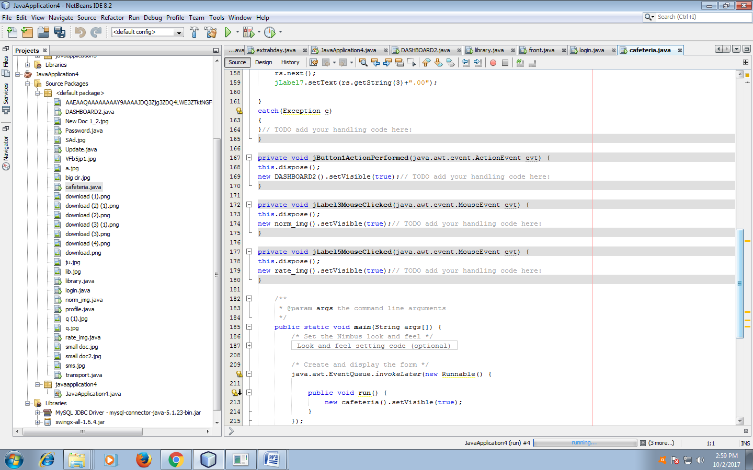

LIBRARY MANAGEMENT:

DESIGN VIEW:

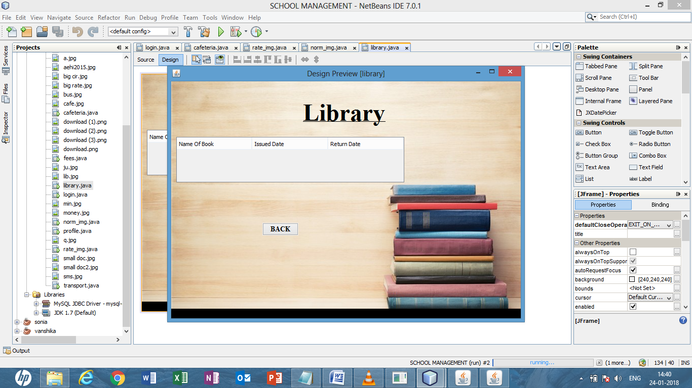

Fig 8: library design view

RUN VIEW:

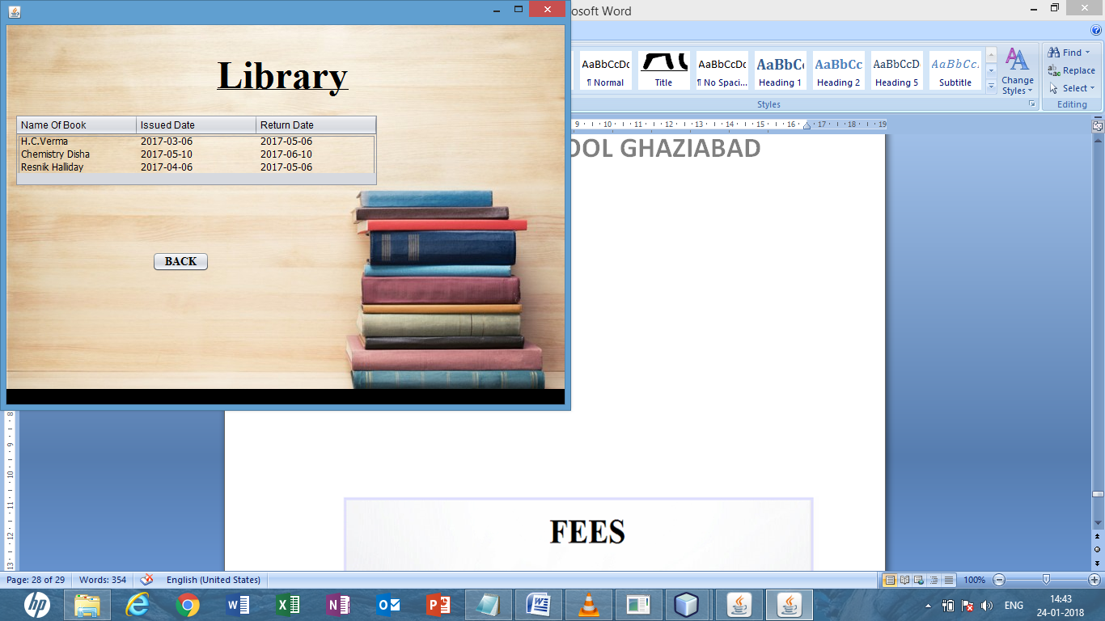

Fig 9:Library run view

SOURCE CODE:

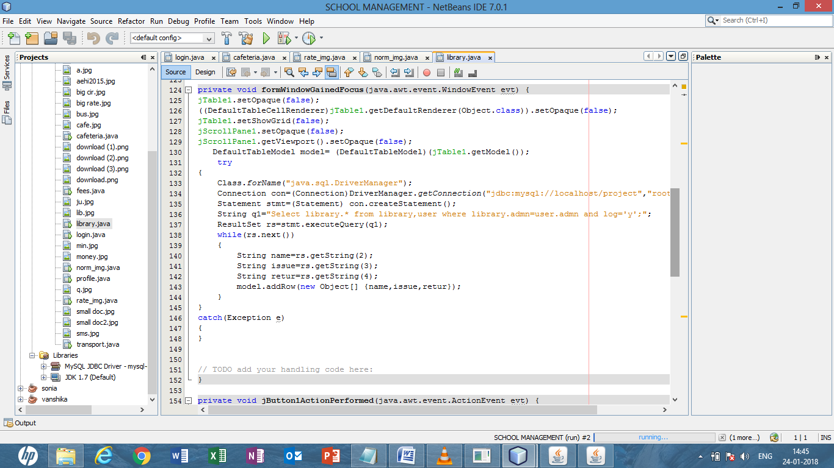

TRANSPORT FACILITY

DESIGN VIEW:

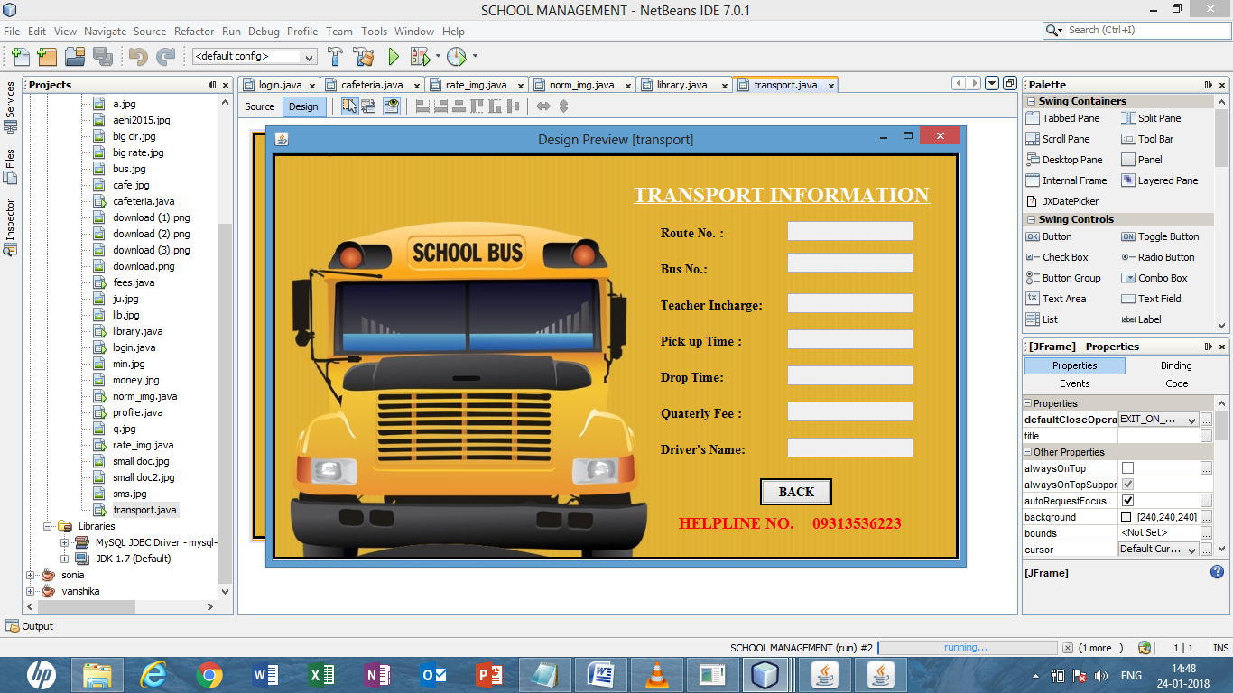

Fig 10:transport design view

RUN VIEW:

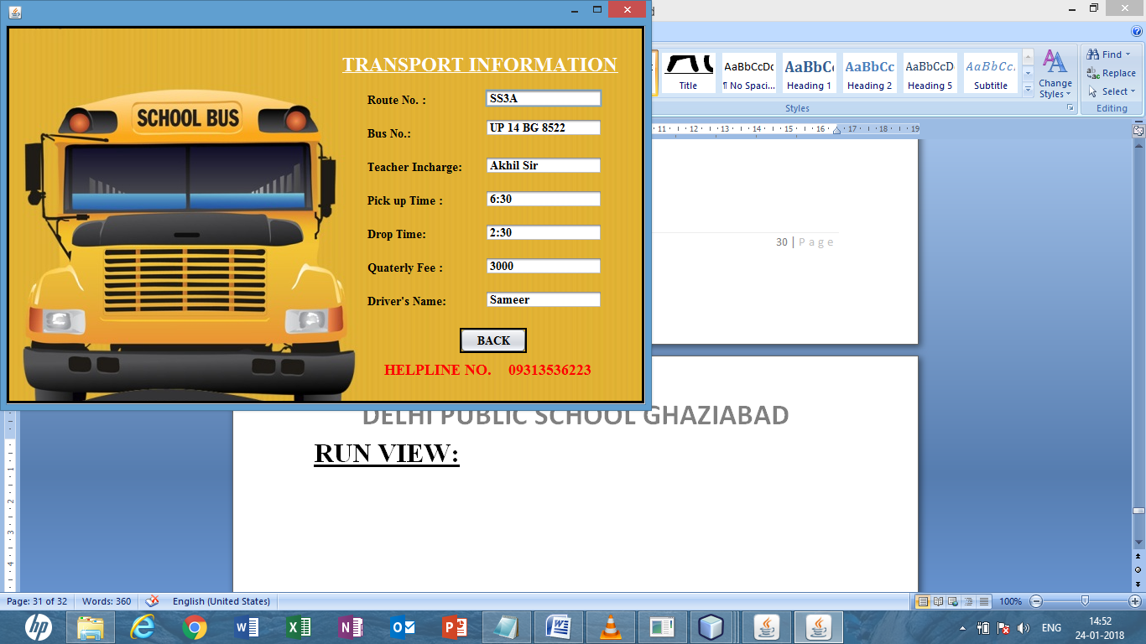

Fig 11:transport run view

SOURCE CODE:

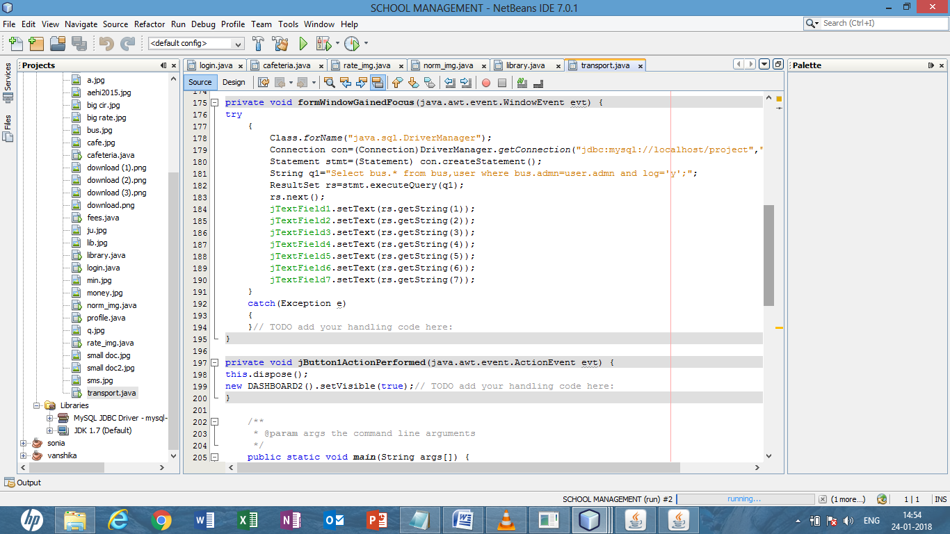

FEE PORTAL:

DESIGN VIEW:

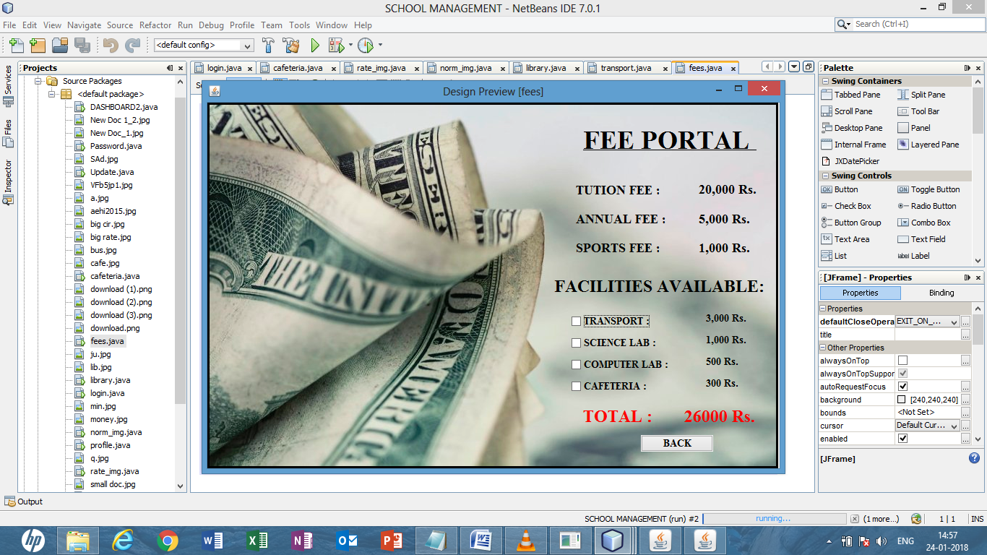

Fig 12:fee portal design view

**RUN VIEW:**

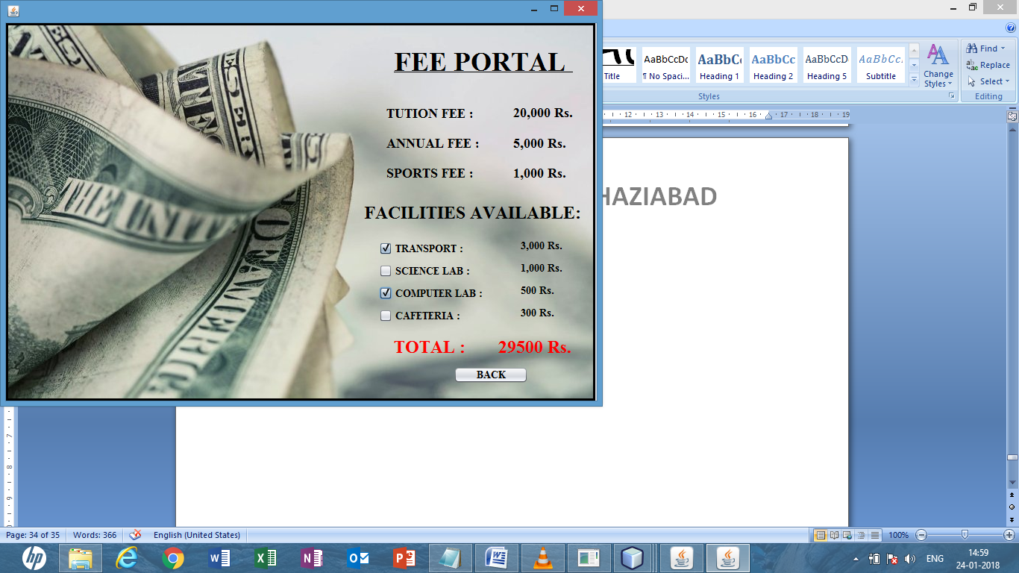

Fig 13:fee portal run view

SOURCE CODE:

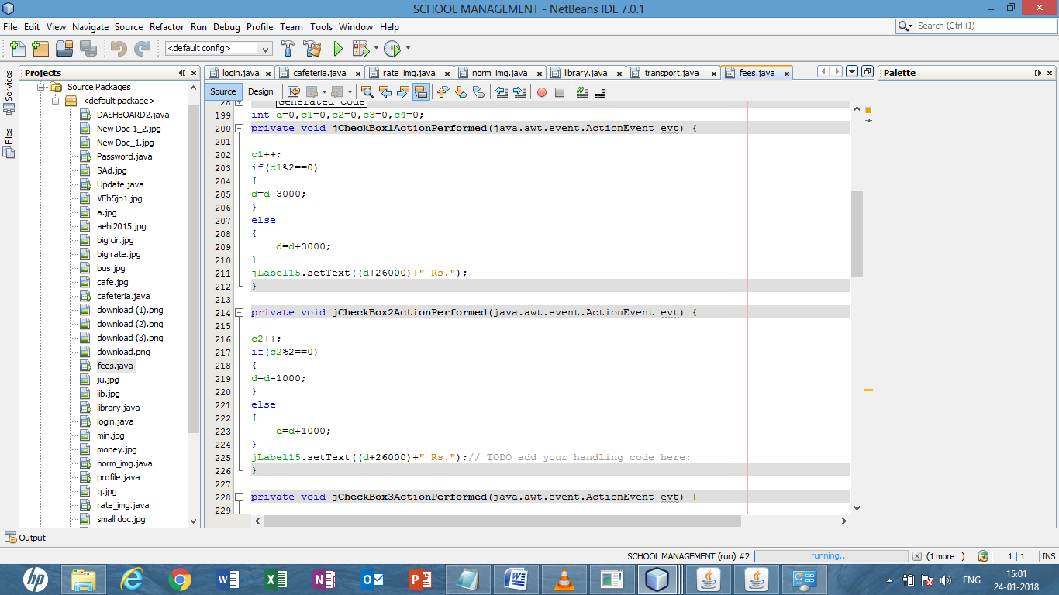

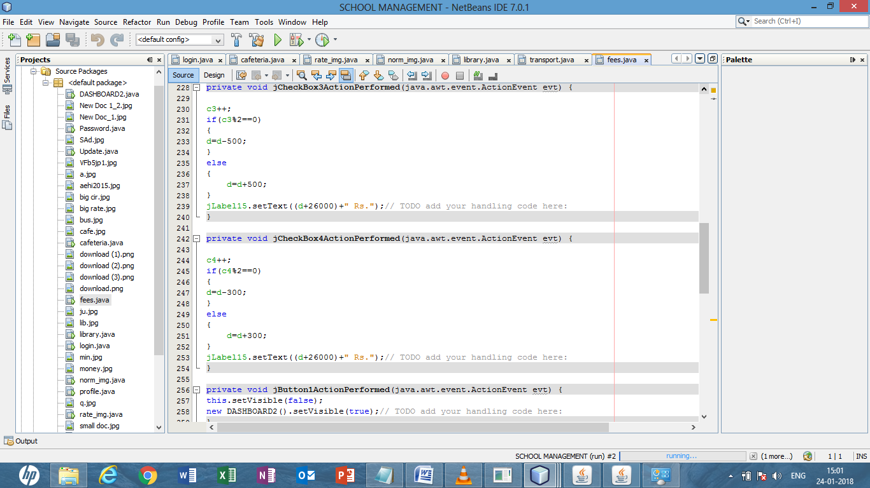

PROFILE MANAGEMENT:

DESIGN VIEW:

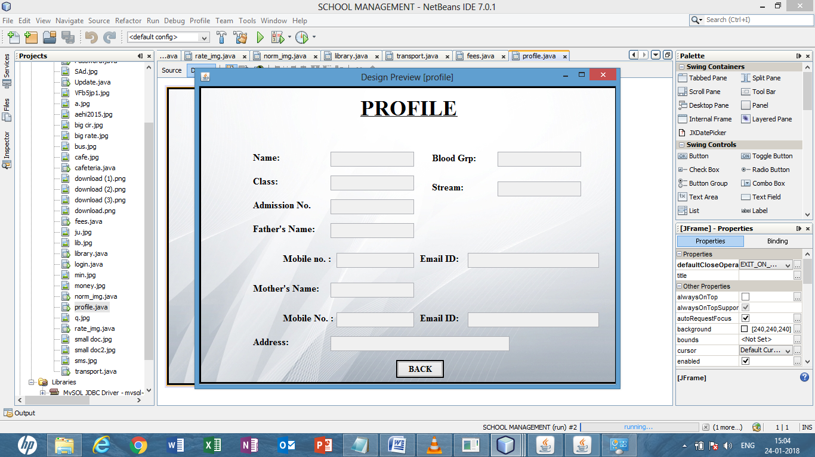

RUN VIEW:

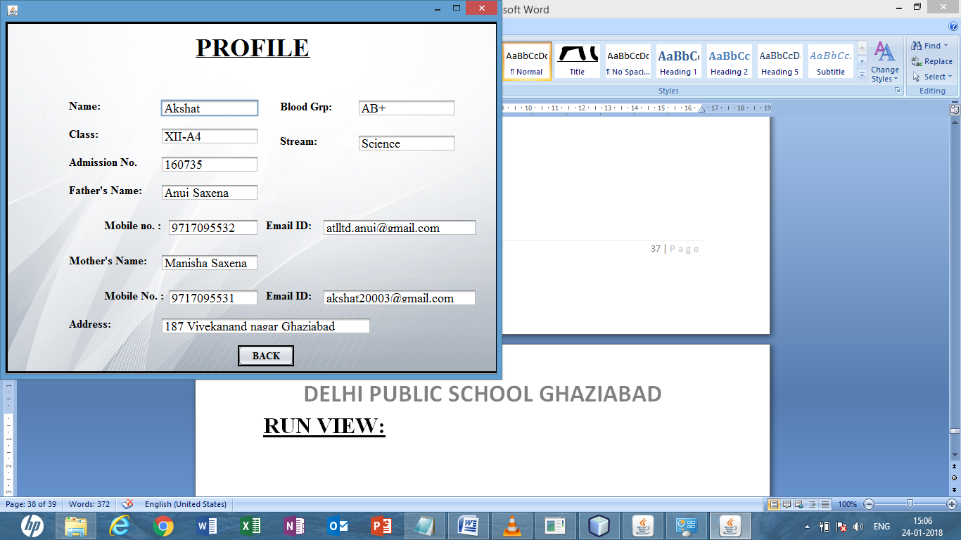

Fig14:student profile

SOURCE CODE:

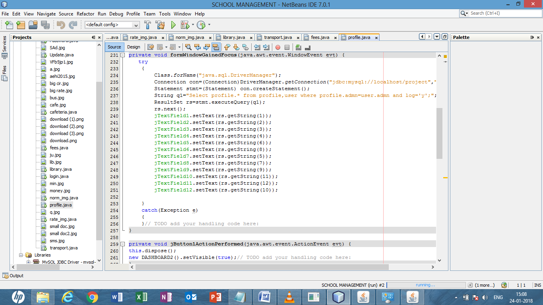

PROFILE UPDATION:

DESIGN VIEW:

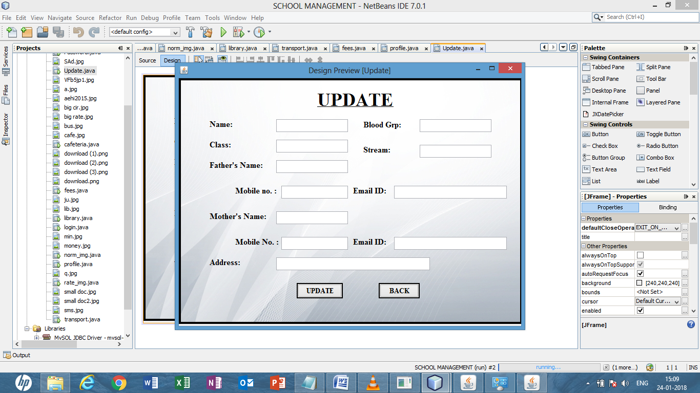

RUN VIEW:

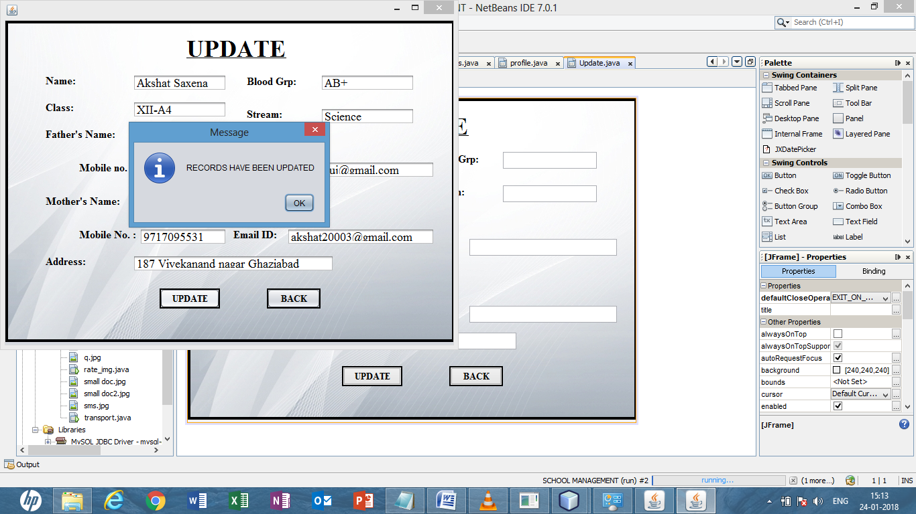

Fig 15:Profile updation

SOURCE CODE:

